2013 AP UNITED STATES HISTORY FREE –RESPONSE QUESTIONS
Stephanie Chow, Brian Chen, Mandy Lai, Andy Hsu
UNITED STATES HISTORY
SECTION II
Part A
(Suggested writing time—45 minutes)
Percent of Section II score –45
Directions: The following question requires you to construct a coherent essay that integrates your interpretation of Documents A-F and your knowledge of the period referred to in the question. High scores will be earned only be essay that both cite key pieces of evidence from the documents and draw on outside knowledge of the period.

- How efficient was America in economic terms before and during WWII?

Document A
Source: The American Economy during World War II, EH.net
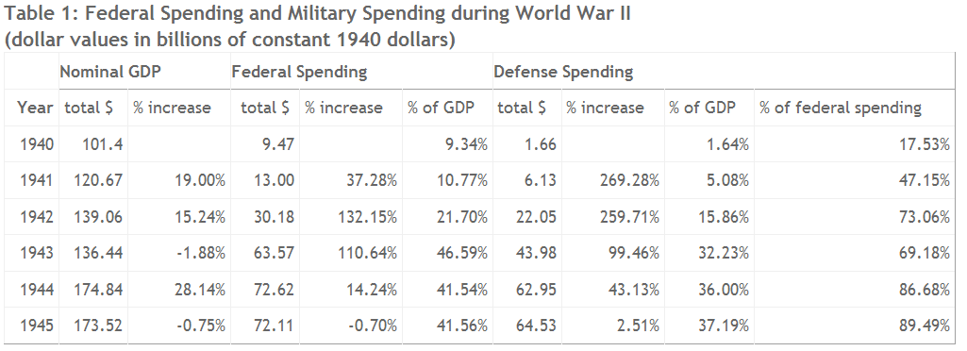

© 2013 Caleroland
Economy during WWII, APUSH, Period 1

Document B
Source: Max Gordon, “Help Britain Defend America”, Committee to Defend America, 1942.
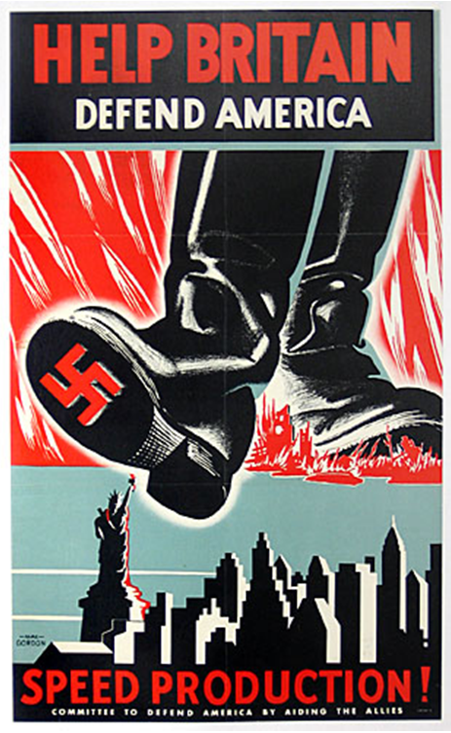

© 2013 Caleroland
Economy during WWII, APUSH, Period 1

Document C
Source: U.S., Department of State, Publication 1983, Peace and War: United States Foreign Policy, 1931-1941 (Washington, D.C.: U.S., Government Printing Office, 1943, pp. 450-53, Message of President Roosevelt to the Congress, January 12, 1939, excerpt
It is equally sensational and untrue to take the position that we must at once spend billions of additional money for building up our land, sea, and air forces on the one hand, or to insist that no further additions are necessary on the other…
Therefore, it has become necessary for every American to restudy present defense against the possibilities…
The survey indicates that of this sum approximately $450,000,000 should be allocated for new needs of the Army, $65,000,000 for new needs of the Navy, and $10,000,000 for training of civilian air pilots.
It is proposed that $300,000,000 be appropriated for the purchase of several types of airplanes for the Army. This should provide a minimum increase of 3,000 planes, but it is hoped that orders placed on such a large scale will materially reduce the unit cost and actually provide many more planes. ..
The additional planes recommended will considerably strengthen the air defenses of the continental United States, Alaska Hawaii, Puerto Rico, and the Canal Zone. […] I suggest that $50,000,000 of the $300,000,000 for airplanes be made immediately available in order to correct the present lag in aircraft production due to idle plants. ..
Of the balance of approximately $150,000,000 requested for the Army, I suggest an appropriation of $110,000,000 to provide "critical items" of equipment which would be needed immediately in time of emergency, and which cannot be obtained from any source within the time and quantity desired-materiel such as antiaircraft artillery, semiautomatic rifles, antitank guns, tanks, light and heavy artillery, ammunition, and gas masks. Such purchases would go far to equip existing units of the Regular Army and the National Guard. ..
I suggest approximately $32,000,000 for "educational orders" for the Army-in other words, to enable industry to prepare for quantity production in an emergency, of those military items which are noncommercial in character and are so difficult of manufacture as to constitute what is known as "bottlenecks" in the problem of procurement. ..
The estimated appropriation of $65,000,000 for the Navy should be divided into (a) $44,000,000 for the creation or strengthening of Navy bases in both oceans in general agreement with the report of the special board which has already been submitted to the Congress, (b) about $21,000,000 for additional Navy airplanes and air material tests...
Devoid of all hysteria, this program is but the minimum of requirements...
I trust, therefore, that the Congress will quickly act on this emergency program for the strengthening of the defense of the United States.
FRANKLIN D. ROOSEVELT
THE WHITE HOUSE,
January 13, 1939.

© 2013 Caleroland
Economy during WWII, APUSH, Period 1

Document D
Source: Santa and Women Protesting Lend-Lease Bill, February 16, 1941
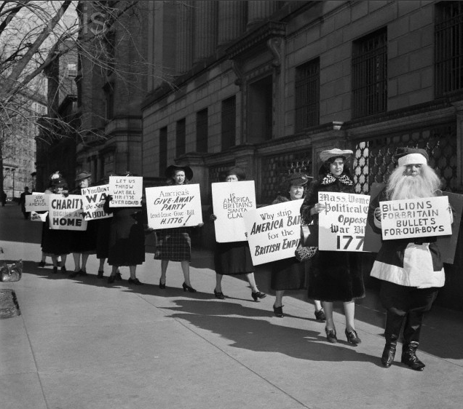
Credits to ©Bettmann/CORBIS

© 2013 Caleroland
Economy during WWII, APUSH, Period 1

Document E
Source: U.S., Department of State, Publication 1983, Peace and War: United States Foreign Policy, 1931-1941 (Washington, D.C.: U.S., Government Printing Office, 1943, pp. 464, Statement by the Secretary of State on the Six-Point Peace and Neutrality Proposal, July 1, 1939
I am still thoroughly convinced that the six-point peace and neutrality program set forth in my letters to Senator Pittman and Representative Bloom on May 27, 1939, would be far more effective in the interests of peace and in keeping the country out of war than the present embargo law or any equivalent.
This legislative proposal was submitted to the appropriate committees of the two Houses of Congress after lengthy conferences with members of these committees and with other leading Members of Congress of all political persuasions. It was my hope and belief that, while this proposal might not contain all that every individual Member of Congress or every official of the executive branch of the Government wished, it would in the present international exigencies be regarded as desirable by a majority of Congress. Its failure to pass the House by a narrow margin is a matter of regret and disappointment from the standpoint of peace and the best interests of this country in its international relations.
This six-point peace and neutrality proposal is not only best calculated to keep this Nation out of war in the event war comes, but also, what is all-important, at this time, best calculated to make a far greater contribution than could the present law or its equivalent toward the discouragement of the outbreak of war.
At the same time, while doing this, it would likewise keep this Government and Nation 100 percent within the limits of universally recognized international law.
In these circumstances, I must continue to urge the adoption of this proposal.

© 2013 Caleroland
Economy during WWII, APUSH, Period 1

Document F
Source: Wartime Rationing
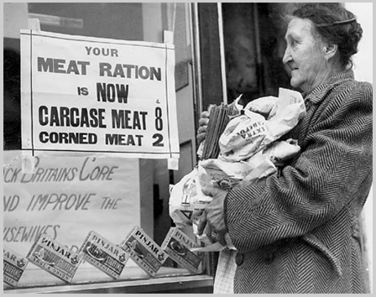
Credits: ©Keep Calm and Carry On

© 2013 Caleroland
Economy during WWII, APUSH, Period 1

AP® UNITED STATES HISTORY
2013 SCORING GUIDELINES
Potential Outside Information
Isolationism
Dawes Plan
Harley-Smoot Tariff
Henry J. Kaijer (Sir Launchalot)
Fair Employment Practices Commission
London conference
Reciprocal Trade Agreement Act
Mechanical cotton picker
Johnson Debt Default Act
Neutrality Acts
Neutrality Acts of 1939
Cash-and-carry
Lend-Lease Bill
World War II
Office of Price Administration
War bongs
Nye Committee
Cordell Hull (Secretary of State)
Franklin D. Roosevelt
Great Depression
Veterans of Foreign Wars
Naval construction act

© 2013 Caleroland
Economy during WWII, APUSH, Period 1

Document A
Document Information
- Federal spending increased from 17.53% to 89.49% in 5 year span during World War II.
- Defense spending increased 269.28% from 1940 to 1941.
Document Inferences
- A huge majority of government money was going into the war effort.
- The war took a greater amount of federal money each year.
- The domino effect that started the war caused an enormous increase in pro-war spending.

Document B
Document Information
- The US was in danger and needed British help to stop Nazi Germany.
- Production was not slow enough and was limiting their war efforts.
Document Inferences
- Britain and America were in an alliance during the war.
- The two allied nations were fighting together to stop Nazi Germany.
- America was helping Britain by sending over equipment.

Document C
© 2013 Caleroland
Economy during WWII, APUSH, Period 1

Document Information
- FDR wanted to focus a majority of government funds on the Army
- Naval forces would be strengthened in United States, Alaska, Hawaii, Puerto Rico, and the Canal Zone.
Document Inferences
- America felt the need to bolster its military power to surface as a world power after the Great Depression
- FDR was a pro-nationalism leader and prioritized military prosperity over humanitarian prosperity
Document D
Document Information
- The lend-lease Bill gave arms and ships to nations in need. These supplies were expected to be returned when they were no longer needed.
- The lend-lease bill was heatedly debated in congress. America ended up spending $50 million because of it.
© 2013 Caleroland
Economy during WWII, APUSH, Period 1

- Senator Taft referred to the lend-lease bill as borrowing chewing gum
Document Inferences
- The lend-lease bill created great opposition with the American people
- The people thought it was like giving away money.
Document E
Document Information
- The Neutrality Act of 1939 allowed European nations to buy war materials on a cash and carry basis.
- Germans couldn’t buy arms from the United States because they were blocked by France and Britain.
- The Neutrality Act of 1939 showed Hitler that Americans were morally on the side of the Allies.
Document Inferences
- Hull supported the six-point peace and neutrality program
- The six- point peace and neutrality program was not passed by Congress
Document F
Document Information
- The Great Depression solemnly crippled American citizens to the point of the government giving out meat/food rations
- Meats were low quality, and barely sufficient.
Document Inferences
- Food rations varied day to day
- A majority of Americans lived off of food rations

© 2013 Caleroland
Economy during WWII, APUSH, Period 1

Sample Response
Americans were increasingly effective in their economic status before and during World War II. This is suggested through the acts and bills passed by Congress, increase in manufacturing, and surge of spending from average citizens.
New legislations passed by Congress throughout World War II demonstrated the increased economic efficiency of the federal government before and during wartime. Secretary of State Cordell Hull, for example, played a significant role in passing the Reciprocal Trade Agreements Act, which lowered tariffs and hoped to achieve relief and recovery by focusing on trade. This was a significant improvement, as the embargo law or any equivalent was greatly detrimental to the economy and ineffective in keeping the country out of war (Doc E). The lower tariffs allowed the US to trade efficiently and effectively with other nations. The Johnson Debt Default Act, which forbade already-in-debt countries from any further borrowing, also provided great economic relief, especially since the US was spending tens of billions of dollars per year on the war effort (Doc A). For a nation spending so great an amount per year, preventing any further monetary losses to foreign nations was highly beneficial.
The increase in manufacturing was also a major factor for the economic efficiency during World War II. The US needed to produce many products for the war at an incredible rate, which boosted the economy by significantly increasing jobs. The Neutrality Act of 1939 allowed European nations to buy war materials on a “cash-and-carry” basis, which meant these nations would have to provide their own ships and pay for the arms in cash. This saved the US a great deal of money because they did not have to ship out the materials, meaning the US could still manufacture products at a high rate without having production outmatch consumption with so many European nations buying from the US. Producing large quantities of war products for Britain further increased economic efficiency in the US. Britain was focused on hindering Nazi Germany’s advancement, and therefore needed a large quantity of war products that was supplied primarily by the US, which led to a great increase in production (Doc E). The need for war products and the quick consumption of these products opened jobs, bringing the US from depression to surplus.
In addition, government spending also suggested economic improvements. Government spending in the years 1940-1945 [Source A] has increased drastically and proved America to be an uprising economic power. In the address to Congress, FDR proposes that $450,000,000 be used to support and refine America's military force [Source C]. The abundance and flexibility of government spending is all due part of the New Deal. The New Deal created programs like Works Progress Administration which opened gates to employment, and earned the government a surplus of money. Government economic prosperity during World War II was enforced by the War Advertising Council which advocated conservative usage, good work ethic, and inspiring enlistment advertisements, all of which were driving forces in the economy of America during and post-World War II.

© 2013 Caleroland
Economy during WWII, APUSH, Period 1

© 2013 Caleroland
Economy during WWII, APUSH, Period 1

© 2013 Caleroland
Economy during WWII, APUSH, Period 1

